Day 47

DIY

DIY Questions:

Alice is presently employed as an intern in a reputable company, her manager has assigned her some tasks related to repository and GitHub. Help Alice to perform the following tasks.

Tasks:

1.Create a remote repository on GitHub.

2.Add a file in the main branch in the GitHub repo

3.Clone the repository to the local server

4.Create a new branch with a name feature

5.Checkout out the branch feature

6.Add a new file to the branch feature

7.Push the branch to the remote repository

8.Create a pull request in Github and merge the feature branch with the main branch.

9.Delete the feature branch in the remote repository

10.Delete the feature branch on local repository

Solution:

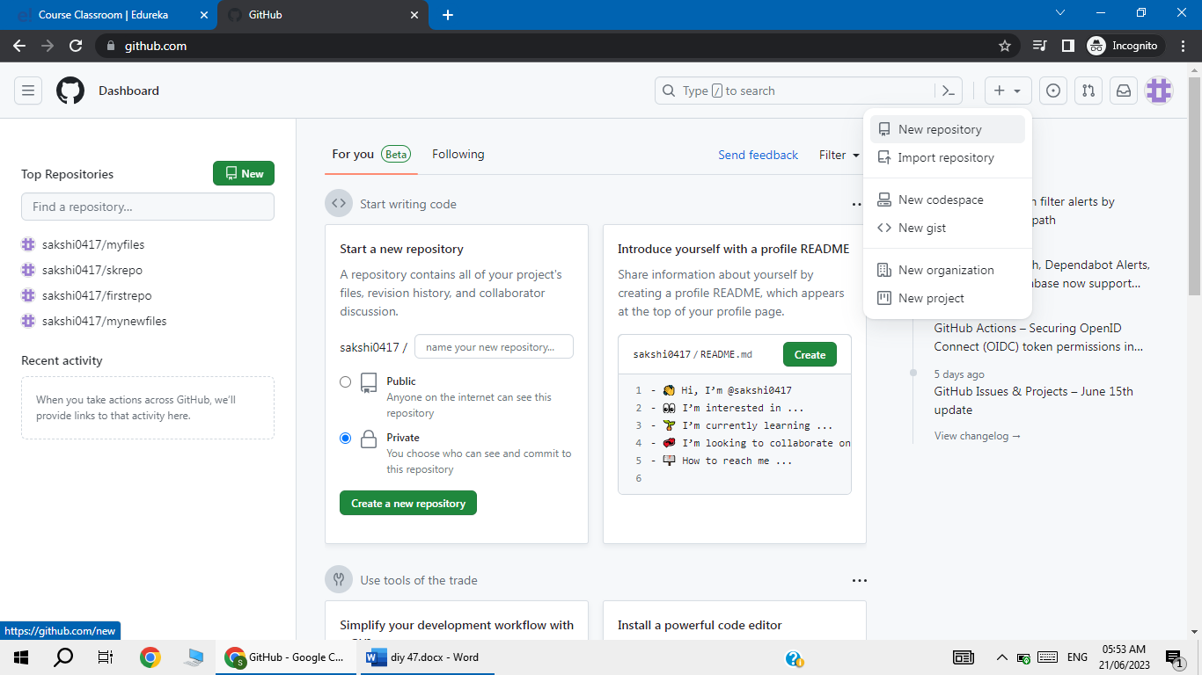

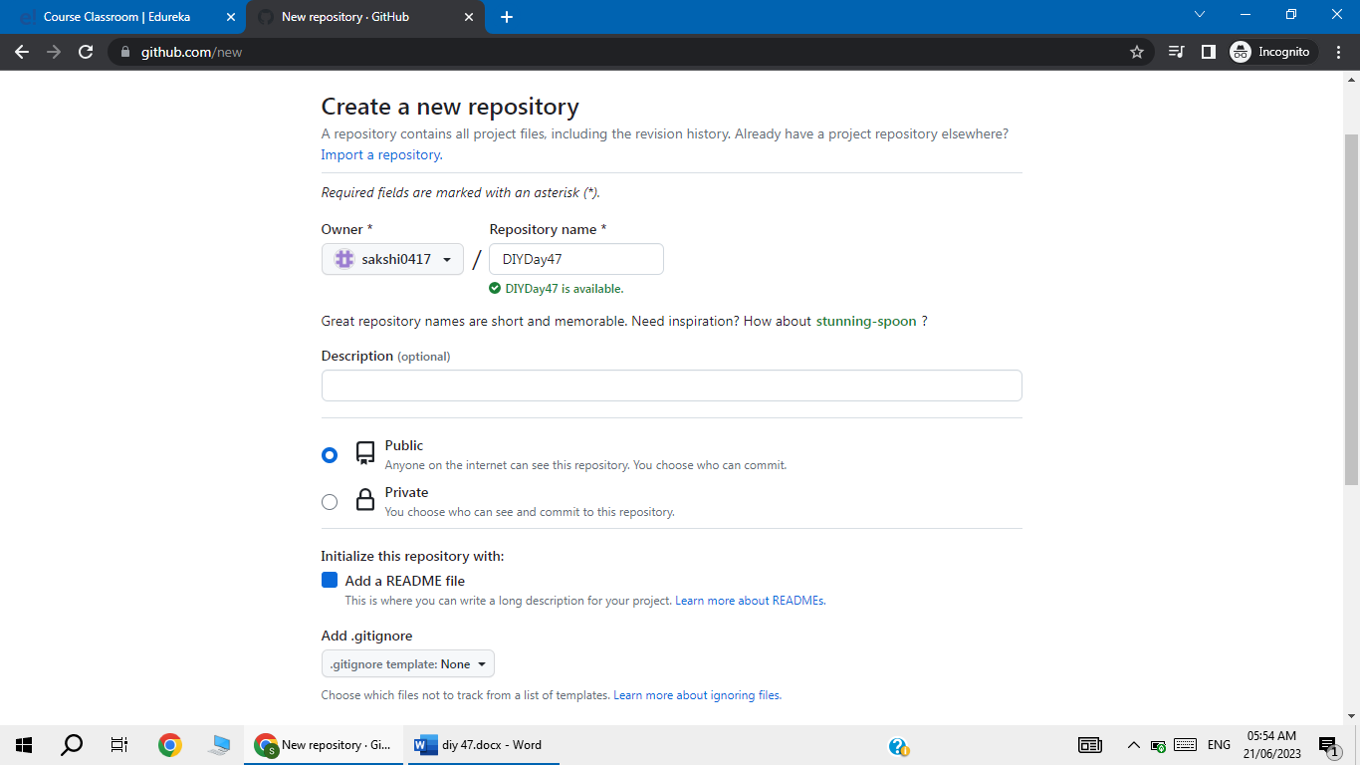

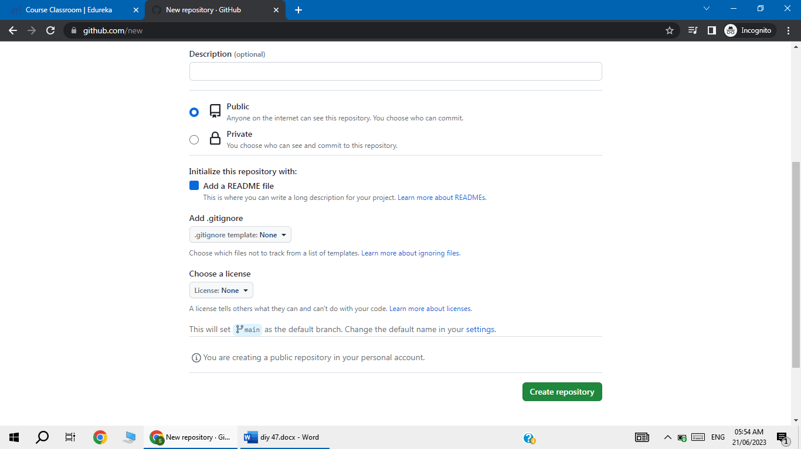

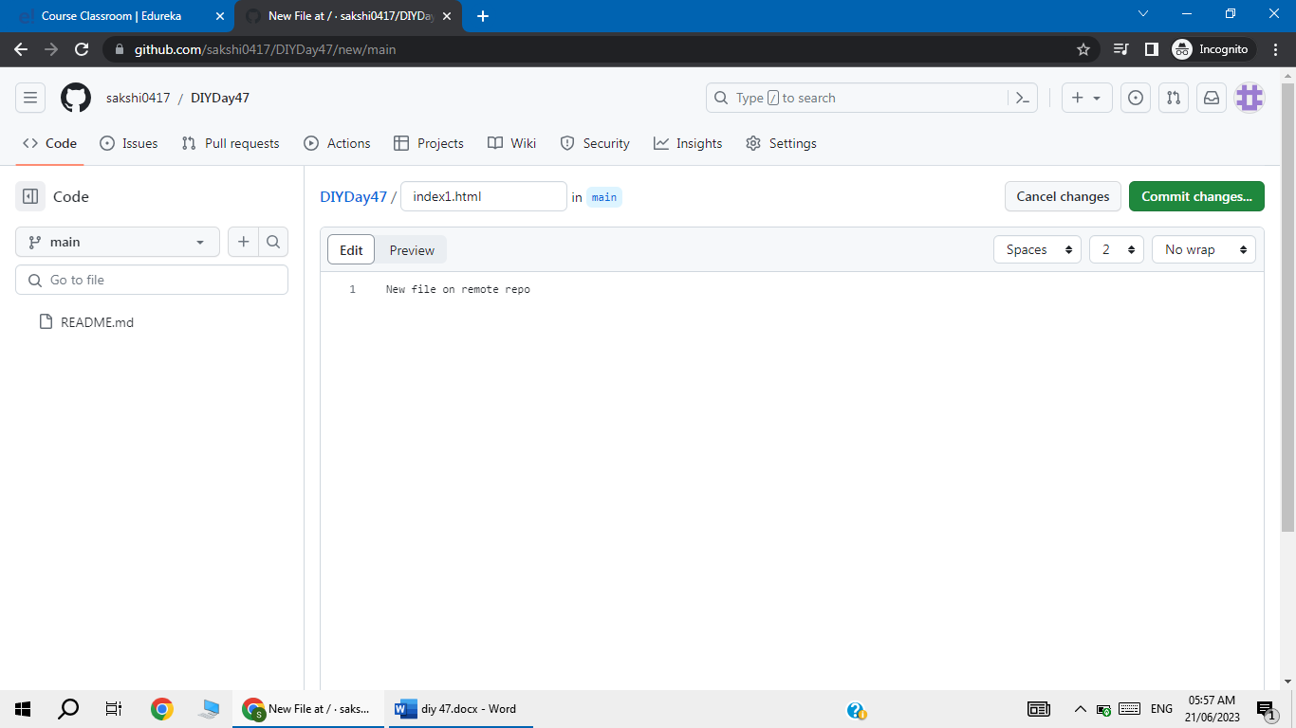

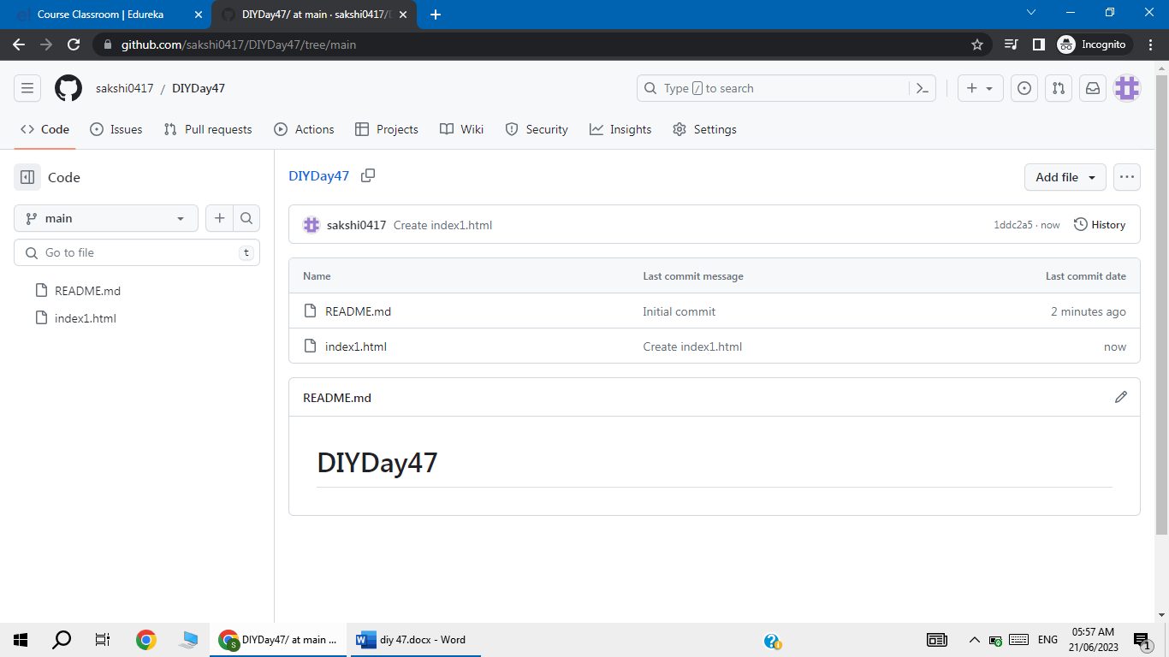

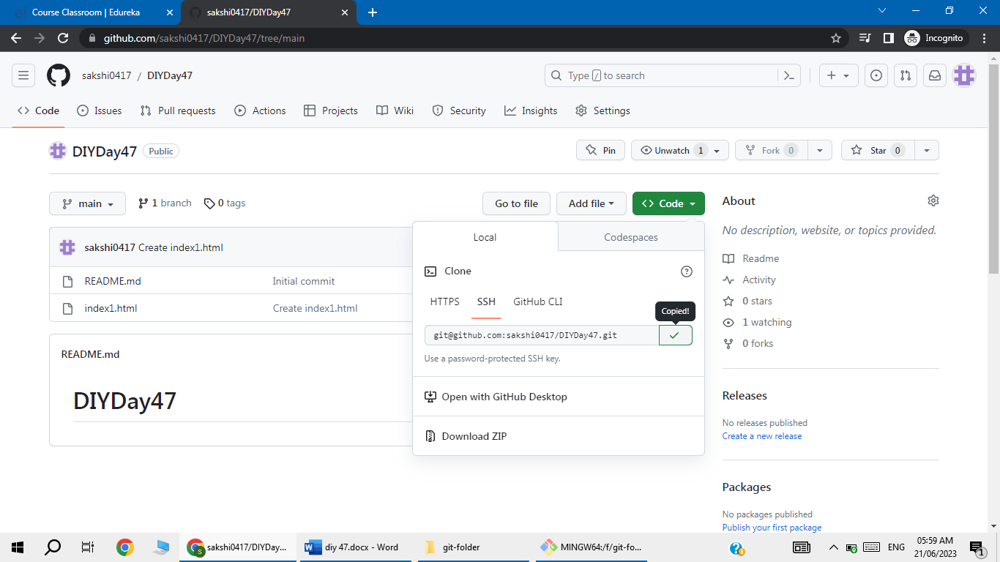

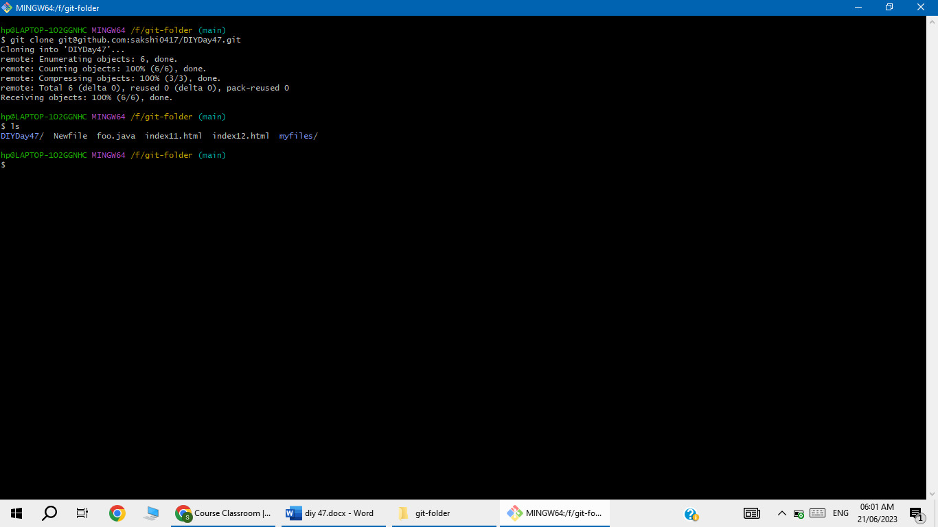

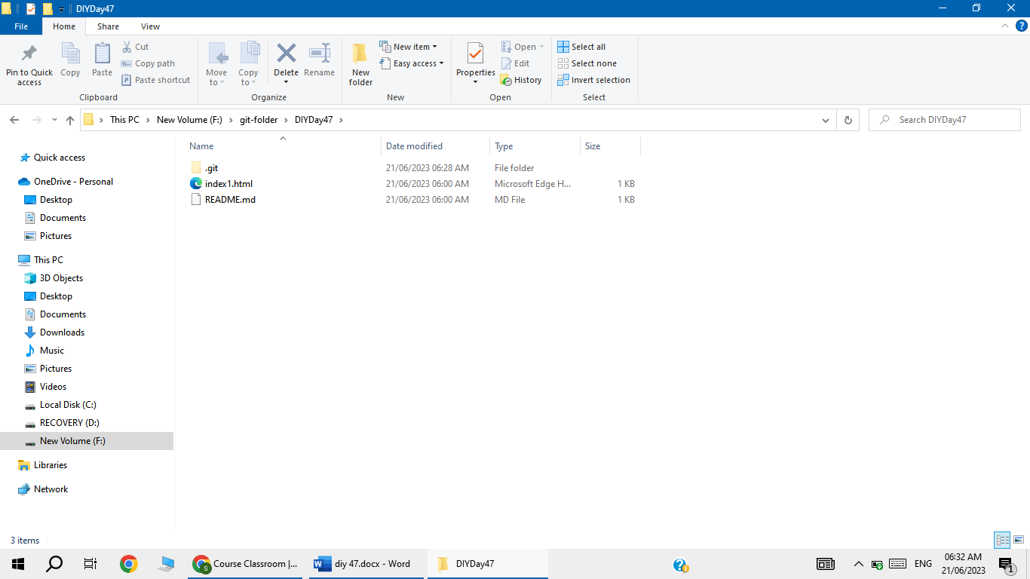

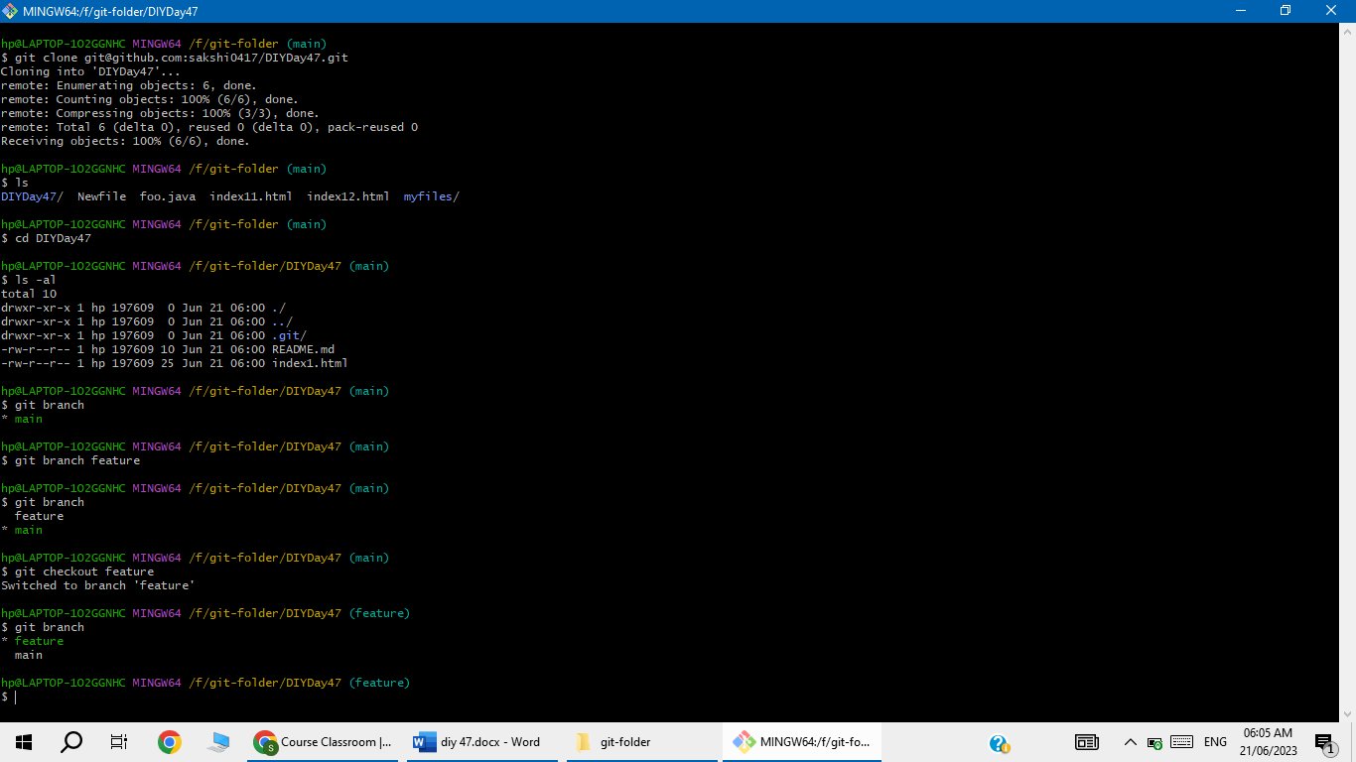

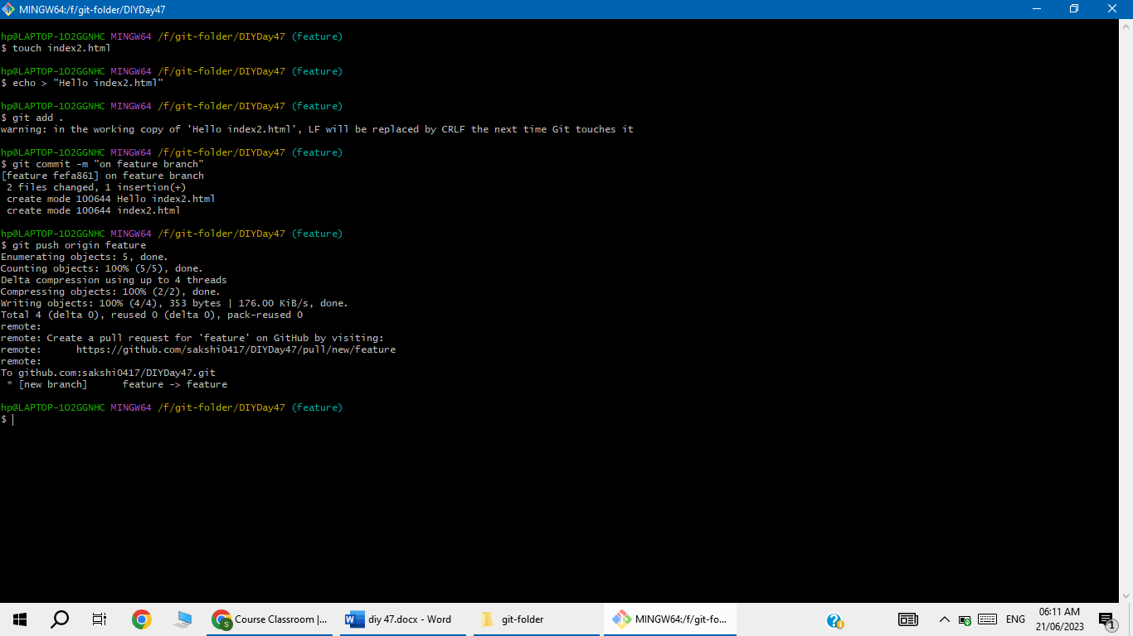

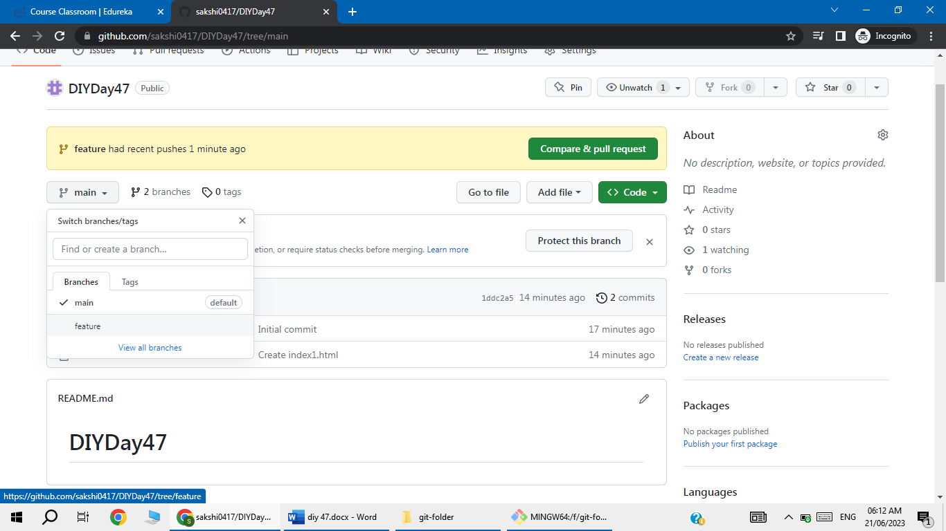

Feature branch is added

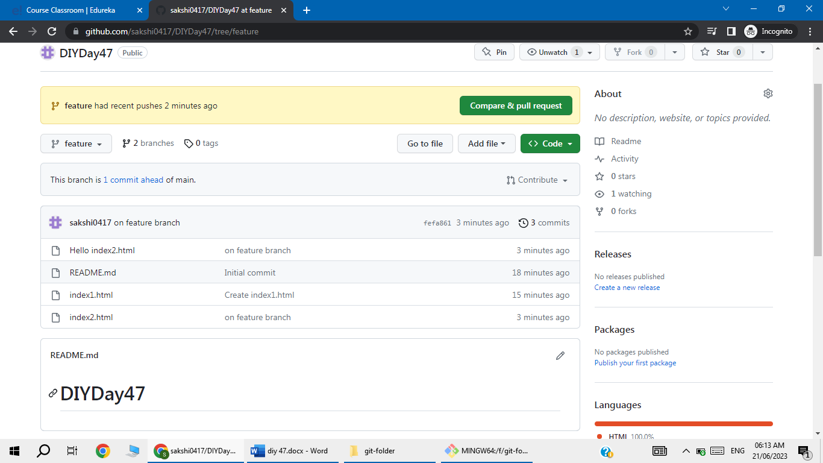

Now click on compare and pull request then click on create pull request

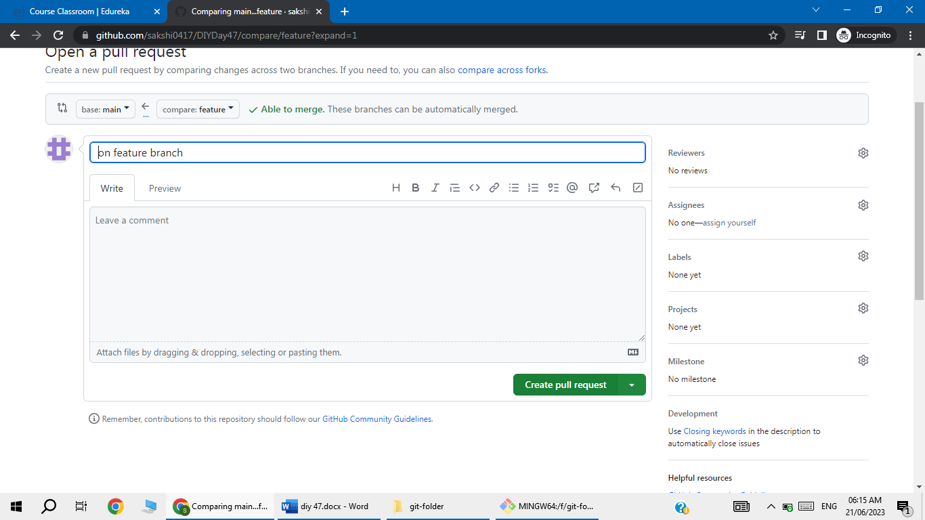

Click on merge pull request

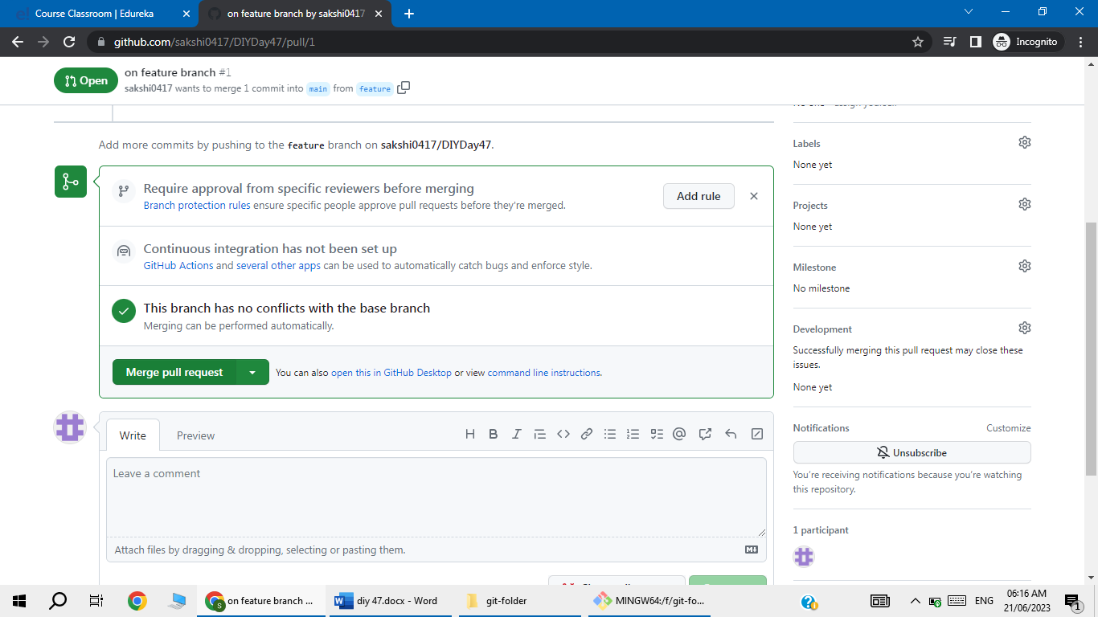

So after merge main branch contain same files that feature branch have

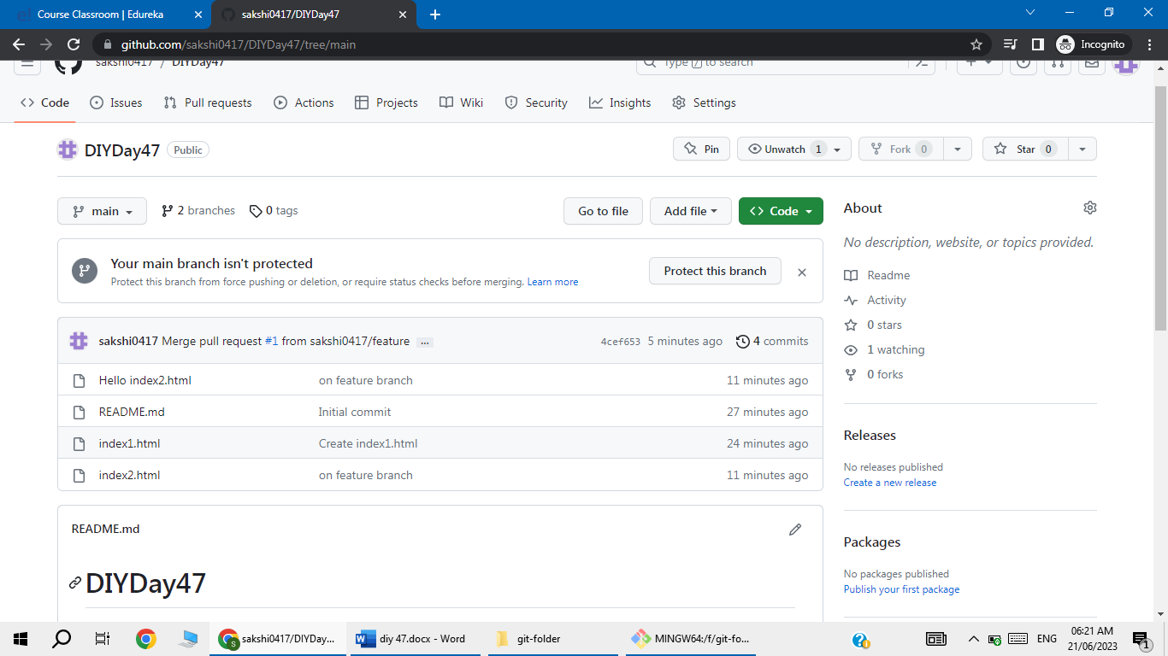

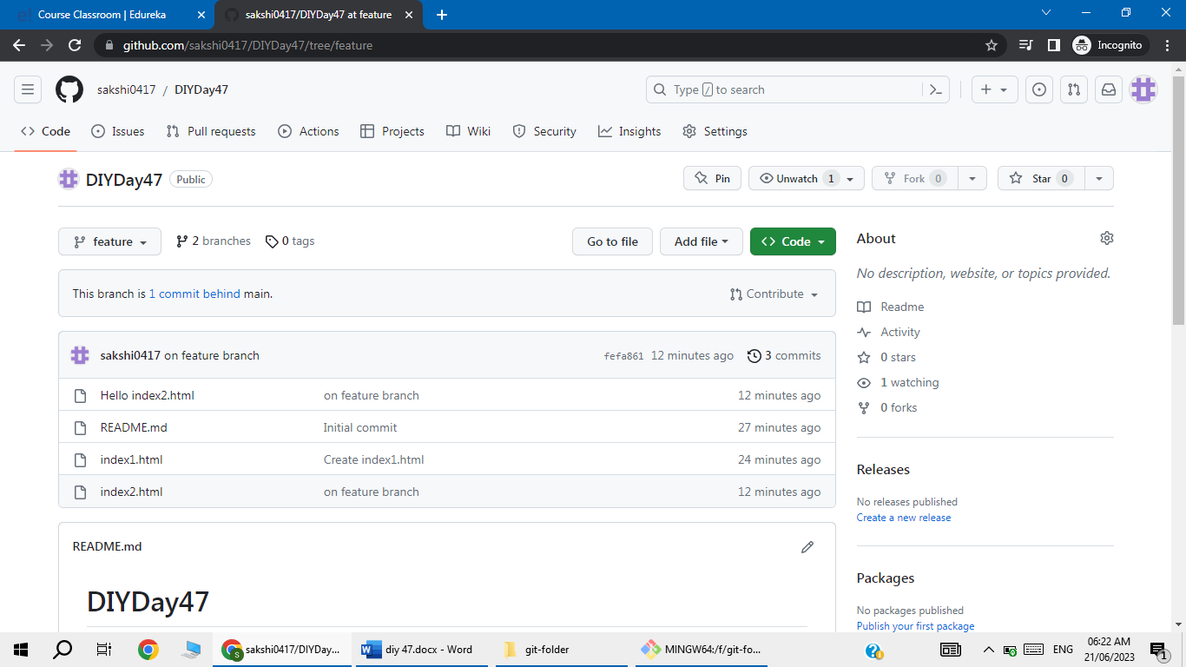

Click on branches

Select featue branch and delete

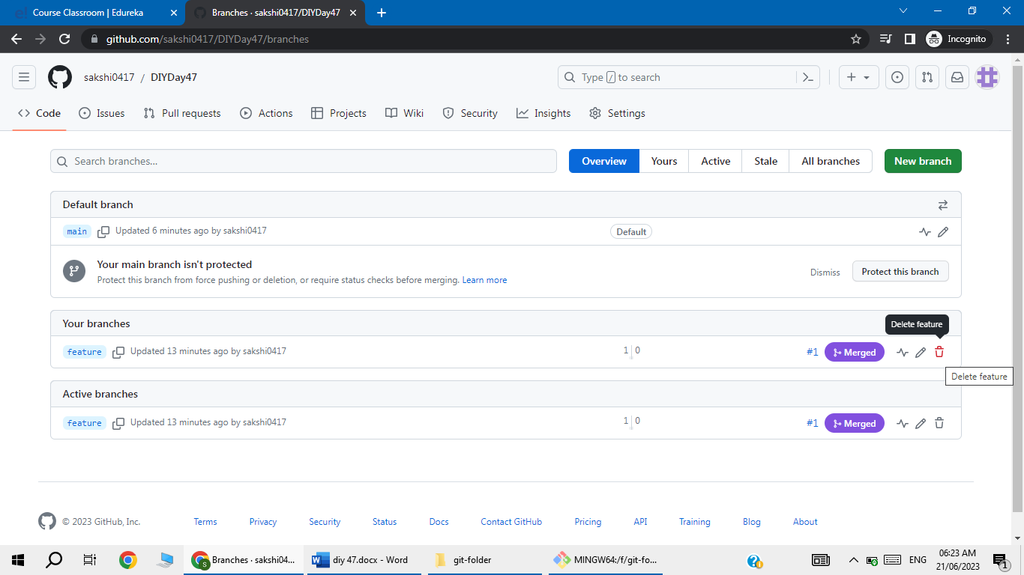

Now to delete the branch locally

